Marcus Engineering has deep experience in life and safety critical systems in Civil and Military flight applications, on both traditional and unmanned aircraft. Marcus Engineering, works with you to understand your product, from requirements to safety to relevant Technical Standard Orders (TSOs) for your product and develop a comprehensive validation and certification package.
Whether your product is an aircraft subsystem meeting a manufacture’s requirements or an item that requires a Technical Standard Order (TSO) Authorization, Marcus Engineering can help guide your product to successful deployment. Whether your product has Minor or Catastrophic failure outcomes, Marcus Engineering can Guide you through the design and certification processes for systems from DAL A (Development/Design Assurance Level) through DAL D.
Development for Aerospace projects from hand carried Electronic Flight Bag equipment to safety critical power systems requires adherence to a diverse set of standards and requirements. From industry standards like ARP4754A (Guidelines for Development of Civil Aircraft and Systems) and DO-178C (Software Considerations in Airborne Systems and Equipment Certification) as well as their guidance and application documentation, FAA AC (Advisory Circular) 20-174 and Development of Civil Aircraft and Systems and FAA AC 20-115C Airborne Software Assurance.
(we will include an image of ARP4754A process waterfall chart)
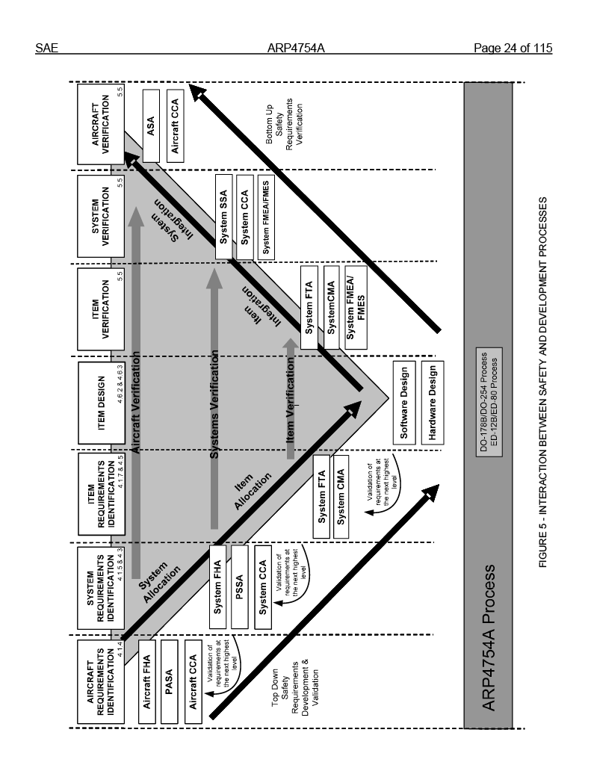
Controlling documents might take the form of the military counterparts to civil requirements for example RTCA DO-160 (Environmental Conditions and Test Procedures for Airborne Equipment) vs. MIL-STD-810 (Environmental Engineering Considerations and Laboratory Tests) and MIL-STD-704 (Aircraft Electrical Power Characteristics) etc.
Controlling documents may also be in the form of a TSO standard from the FAA or a ETSO (European Technical Standard Order) from EASA that defines the minimum performance standard for specified materials, parts, and appliances used on civil aircraft.
Marcus Engineering uses disciplined R2E™ (Risk Reduction Engineering™) Design Controls and sophisticated Hardware (link) and Software (link) development processes to ensure that functional, performance, and customer requirements are met. But meeting the requirements is only half of the story, it is critical that there is documented traceability from the base requirements through the complete development processes, from Requirements through the Hazards process, to specifications, implementation and verification and validation.
Marcus Engineering can address many regulatory guidelines seamlessly and efficiently including:
- SAE ARP4754A; Guidelines for Development of Civil Aircraft and Systems
- ARP4761; Guidelines and Methods for Conducting the Safety Assessment Process on Civil Airborne Systems and Equipment
- RTCA DO-178C; Software Considerations in Airborne Systems and Equipment Certification
- RTCA DO-297; Integrated Modular Avionics (IMA) Development Guidance and Certification Considerations
- RTCA DO-254; Design Assurance Guidance for Airborne Electronic Hardware
- RTCA DO-160G; Environmental Conditions and Test Procedures for Airborne Equipment
- MIL-STD-810H; Environmental Engineering Considerations and Laboratory Tests
- MIL-STD-704F; Aircraft Electric Power Characteristics
- MIL-STD-461G; Requirements for the Control of Electromagnetic Interference Characteristics of Subsystems and Equipment
- MIL-STD-464D; Electromagnetic Environmental Effects Requirements for Systems
- And many more…
As well as the wide array of FAA ACs and EASA AMCs that provide guidance and interpretation for the above standards as implemented in Civil Aircraft.
R2E™ (Risk Reduction Engineering™) is core to Marcus Engineering’s efficient and quick to market Design Controls for Medical Device development. Fundamentally R2E™ is a process of minimizing risk, maximizing clarity, and addressing fundamental requirements and design issues early in the design process while they are still manageable. The R2E™ design approach drastically increases on time delivery, customer transparency, and satisfaction. To learn more about R2E™ Risk Reduction Engineering™ please read the full process description HERE.

More content
Marcus Engineering has deep experience in high performance battery management systems, from ultra-low power wirelessly charged IoT devices to 300kWh, 2000lb lithium battery systems. Marcus Engineering has deep experience in building battery management for safety and life critical applications, as well as novel battery chemistries like Lithium iron phosphate and Lithium–sulfur in addition to Lithium ion and Lithium–polymer chemistries.

